Google Classroom How-To Guide

On a computer
The best way to access Google Classroom is using the Chrome browser. First, sign in to Google Chrome using your @stokehill.school account. This is the account you use at school. This information should be in your reading record.
If you are already signed into another account at home, you will need to add your school account by clicking on the circle that shows who is currently signed in.
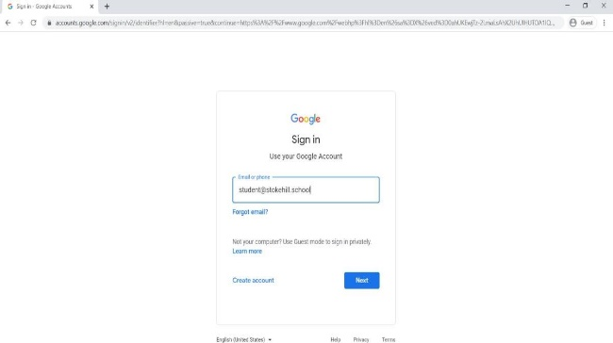
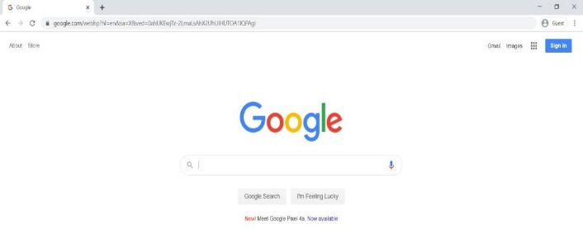

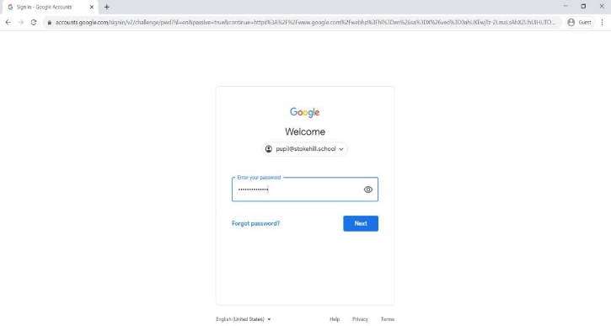

You’ll be taken back to Google’s homepage, but you’re now signed in. There’s a grid of apps in the
top right. This has lots of apps, including:
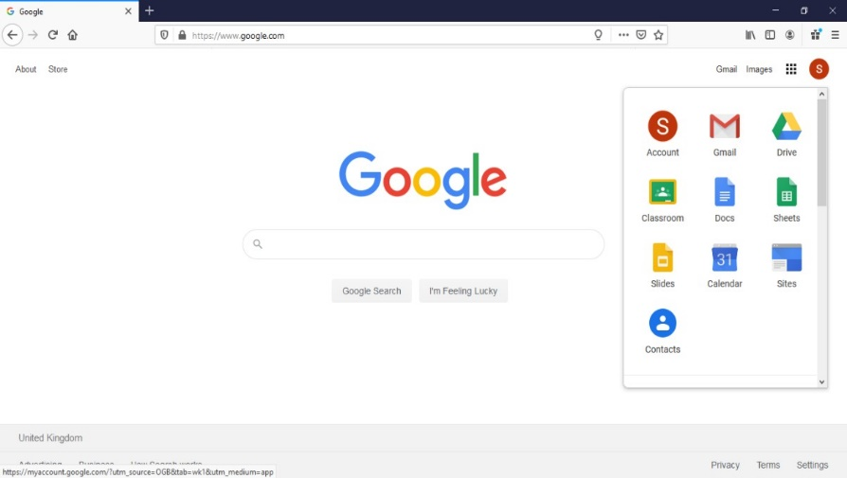
- Google Docs, the word processor
- Google Drive, where all of your work is saved
- Google Classroom, where teachers will post work and resources

Click the Google Classroom app to see your classes. You should already have joined your class, so click on the class name to enter your google classroom.
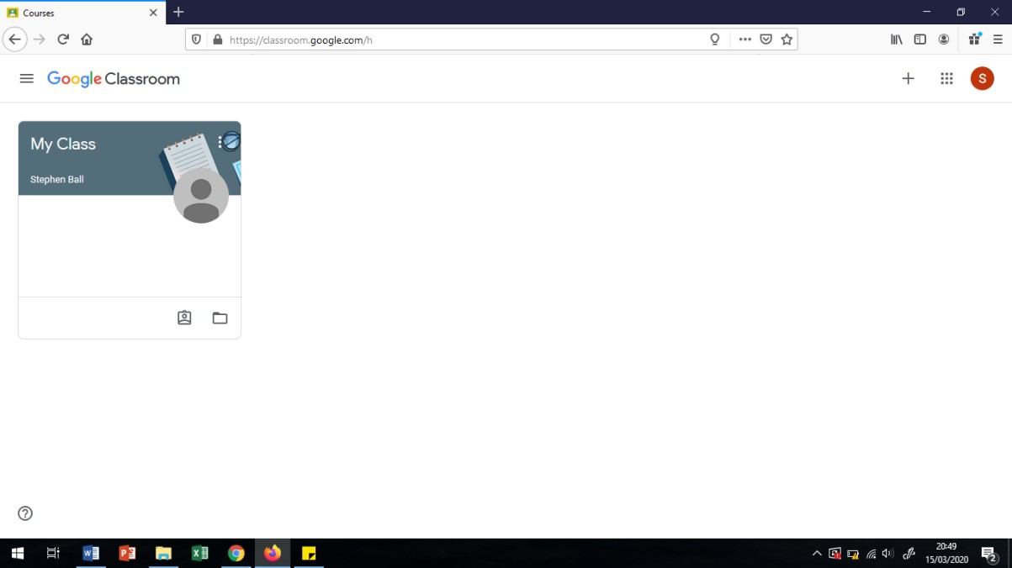

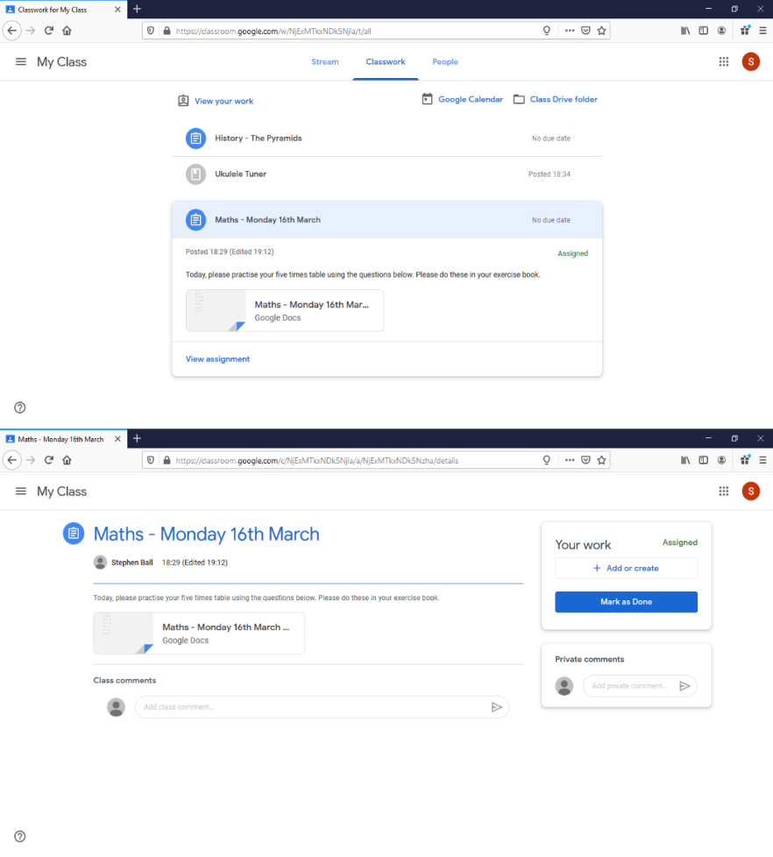
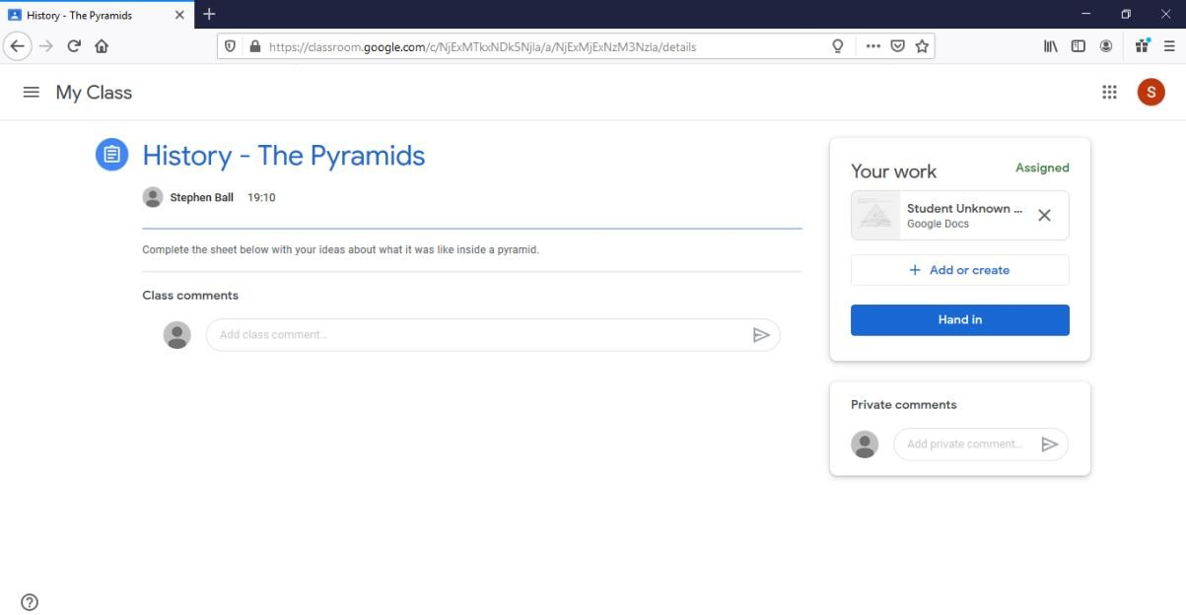
Once in the classroom you will see any work or announcements posted in the stream, and you can view your assignments in the classwork tab.

Your teacher can post links for you to look at.

Or they may post documents for you to directly edit.

You can use also use the Add or create button to create a new google document, or upload a photo of any work you have done offline.

On a Phone or Tablet
On a smartphone you will need to download the google classroom app from the app store or Google play store.
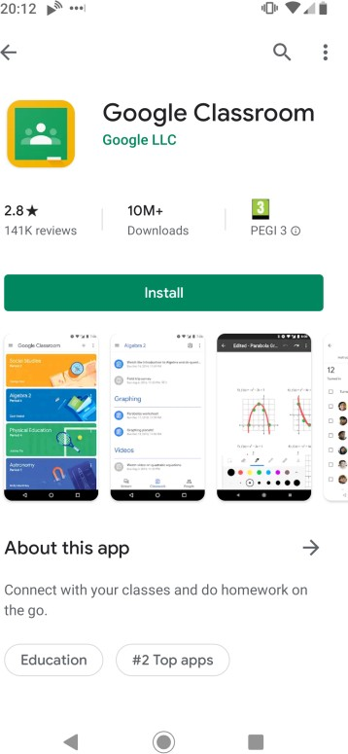
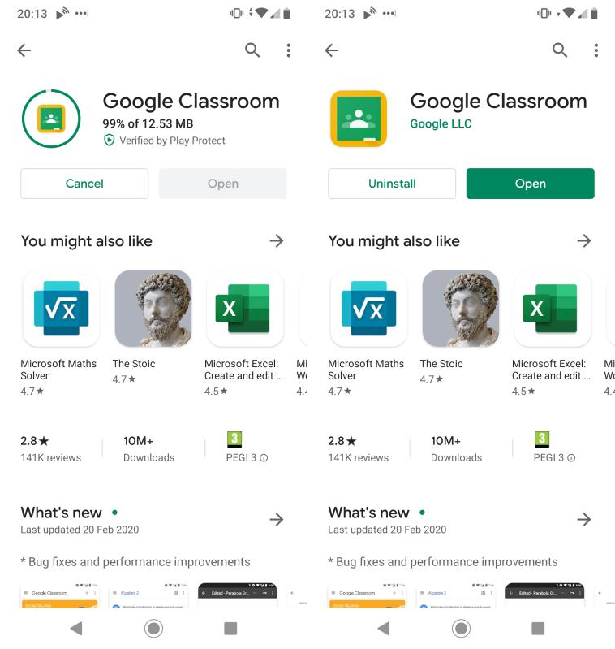
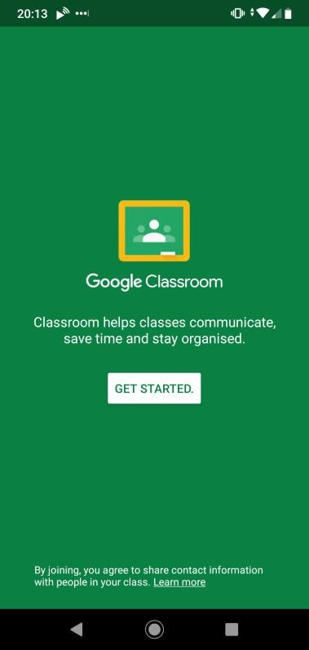

Then you’ll be asked to choose an account. You’ll need to click “add an account”, and add your
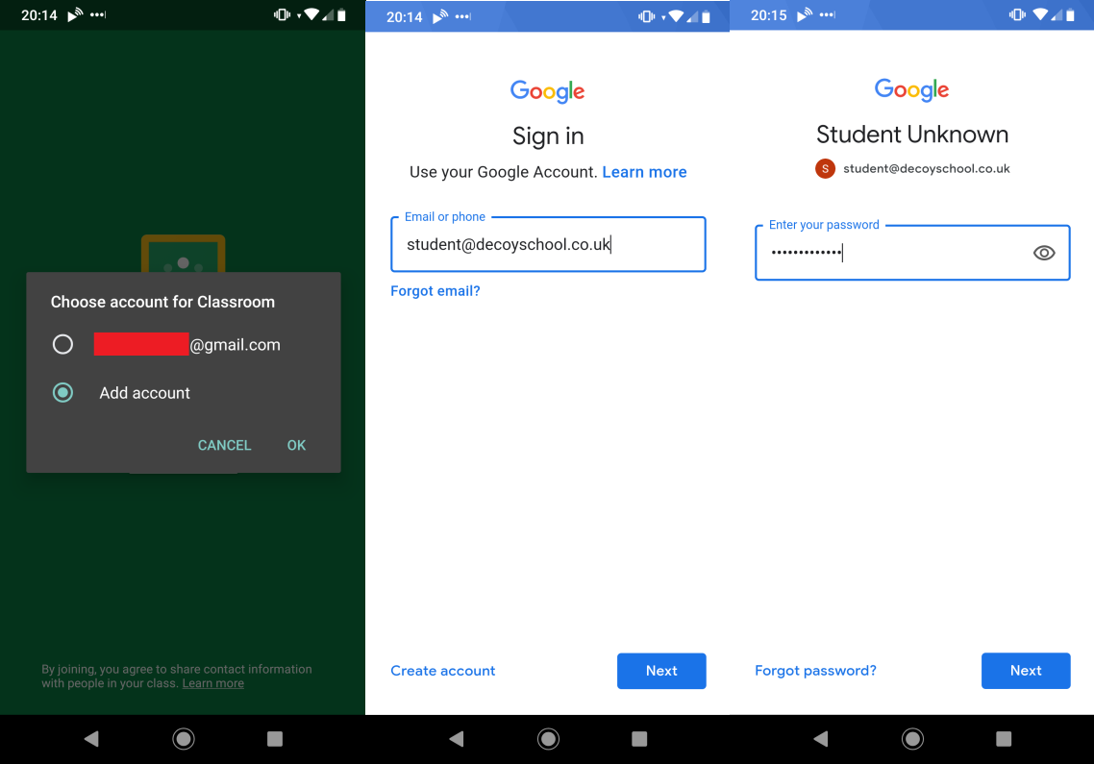
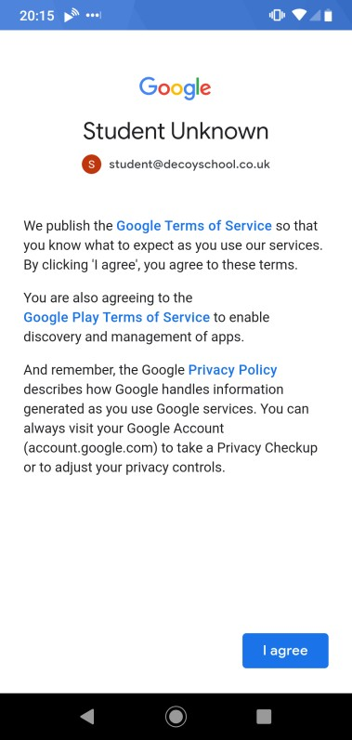
@stokehill.school account.

Student@stokehill.school
Student@stokehill.school

Student@stokehill.school

Now, you can go to your class, and you can see the activities and resources your teacher has posted.
It’s very similar to using it on a desktop computer.
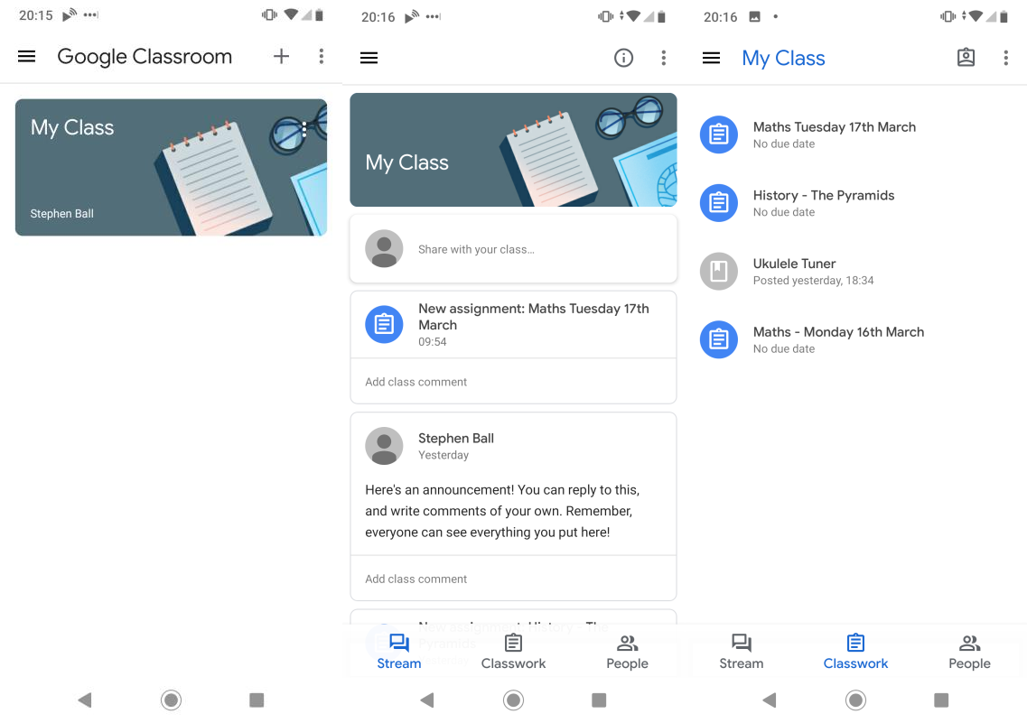

At the bottom, you can see your work for each assignment. It’s a bit fiddly to try writing your work on a phone, but you can see the instructions and worksheets, and use these to help you write your work in your workbook.
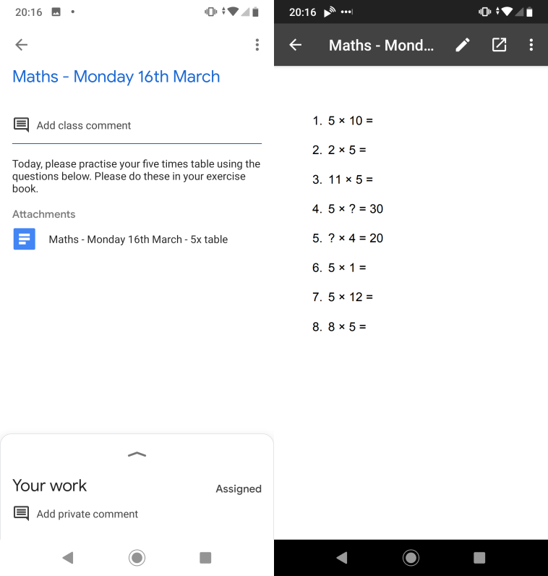

Finally, you can use the menu on the left side to add accounts and choose which account is being used, so siblings can be signed in on the same device.
